DATE:

Survey request for the French ink regulation on inks in the printing on packaging, etc.

We would like to express our gratitude for your continuous support of our procurement and production activities

On May 3, 2022, France’s Ministry of Ecological Transition (MTES) released “Order of 13 April 2022 specifying the substances contained in mineral oils whose use is prohibited on packaging and for printing to the public” to ban the use of mineral oils in ink. This regulation came into force on January 1, 2023.

Since packaging and printed materials are subject to this regulation, we have decided to conduct a survey targeting our suppliers delivering packaging and printed materials to us. Thank you very much for your cooperation.

■Restricted substances

　Substances contained in mineral oils. No CAS No. is assigned for both substances.

1. MOAH（Mineral Oil Aromatic Hydrocarbons）：Mineral oil aromatic hydrocarbons with 1 to 7   
   aromatic rings.
2. MOSH（Mineral Oil Saturated Hydrocarbons）：Mineral oil saturated hydrocarbons with 16 to 35 carbon atoms.

　＊A mixture of hydrocarbons produced by refining petroleum, such as aromatic hydrocarbons(AH), open-chain or cyclic saturated hydrocarbons(SH).

■Target items

　✓ Packaging：All items intended for containing products, regardless of how they would be used.

　✓ Printed paper distributed to the public：All printed paper except packaging and paper for hygienic application.

1. Printed paper intended for commercial promotion. (Product catalogs, Direct Mail(DM), etc.）
2. Printed paper other than above to be distributed to public.

■Enforcement date

January 1, 2023

Note) Enforcement dates vary depending on the target substances and target items.

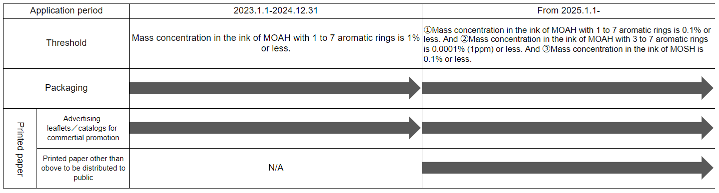

■Description of the regulations

Ban on the use of mineral oils in ink on the target items.

Note) Once the regulations become effective, any items that contain the restricted substances would be prohibited to be imported. However, for items imported before the enforcement date, a period of not more than 12 months will be given to dispose of the stock.

■Description of the survey

We will conduct survey with the following questions regarding your company's products (packaging and printed materials) supplied to …. Company name…

**Survey response sheet**

1. Is there printing on any of your products which are supplied to …. Company name….?

　No　→ This is all for the questions.

　Yes　→ Please continue to answer question #2 onwards.

1. Are mineral oils contained in the printing on your product?

　Not contained　→This is all for the questions.

　Contained

→ Please answer the rest of the questions.

　Unknown

1. Are those inks subject to this mineral oil regulation in France?

　Not subject　→ Please indicate the reasons.

　（　　　　　　　　　　　　　　　　　　　　　　　　　　　　　　　　　　　　　　　　　　　　　　　　　　　　　）

　Subject

→ We will contact you.

Please indicate the information about the point of contact in your company.

　Unknown

　　Point of contact：Name　　　　　　　　　　　／Division　　　　　　　　　　　　　　／Job title

　　Email address：

　　Telephone No.：

■Information about the person responding（indicate “same as above” if responded by the point of contact above）

　　　　　　 Name：

　　　　　 　Division：

　　　　　　　Job title：

　　　Email address：

　　 Telephone No.：

■Contact：……… Email address：………………

■Submission due date：……………

■Please fill out this survey sheet and send it back our email address.